FOR YOUR PRAYERS
THE PARISH CHURCH OF

www.allsaintstwickenham.co.uk
ALL SAINTS
TWICKENHAM
The Sick in body, mind or Spirit
D Catherine Wybourne, Tony Pescott-Day, Sam Cash, Bradley Smith, Lesley Harris, David Ballard, Rex Burwood, Harley Price, Vera Jolly, Richard Lowe, Kate Slack, Steve Randall, Chris Ctori, Laura Begnoche, Merle Greisbach, Maureen Mills, Rae,Margaret McDonald.

Those who have died.
Geoff Prince

Those whose anniversary of death is about now

2 Gertrude Wilmott
11 Fr John Willmington
14 Ian Patterson
16 William Balderson
21 Gertrude Hird
23 Alma Hammond
23 Michael Appleton-Collins
25 Barbara Board
27 Elizabeth Shewan
28 Betty McCreary
30 Madge Briggs

NEXT SUNDAY

EASTER SUNDAY
Of the Lord’s Resurrection
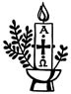

10am PARISH MASS

6pm VESPERS & BENEDICTION

Followed by a bring and share Party

WELCOME TO MASS
If you’re a visitor make yourself known to the parish priest.
Tea and coffee are served after Mass, please join us.
Little Saints – our Junior Church meet in the Hall
Please make sure your Mobile Phone is switched off.

Please take this sheet away with you

BEFORE MASS PLEASE KEEP A SENSE OF STILLNESS AND QUIET AS WE WAIT TO WELCOME THE LORD

PALM SUNDAY
Of the Lord’s Passion

10am BLESSING OF PALMS, PROCESSION & PARISH MASS
Meet outside Vicarage

6pm VESPERS & BENEDICTION

CONFESSIONS BEFORE EASTER

Fr Alex will be available at 6pm each evening this week

THE LITURGY OF HOLY WEEK

MONDAY
0900 Lauds (Morning Prayer)
1830 Vespers (Evening Prayer)
1900 MASS & ADDRESS
2130 Tenebrae

TUESDAY
0900 Lauds
1100 CHRISM MASS (St Andrew, Holborn)
1830 Vespers
1900 MASS & ADDRESS
2130 Tenebrae

WEDNESDAY
0900 Lauds
1830 Vespers
1900 MASS & ADDRESS
2130 Tenebrae

MAUNDY THURSDAY
0930 Lauds

THE SACRED TRIDUUM
Christ redeemed us all and gave perfect glory to God principally through his paschal mystery: dying he destroyed our death and rising he restored our life. Therefore the Easter Triduum of the passion and resurrection of Christ is the culmination of the entire liturgical year. Thus the solemnity of Easter has the same kind of preeminence in the liturgical year that Sunday has in the week. The Easter Triduum begins with the evening Mass of the Lord’s Supper, reaches its high point in the Easter Vigil, and closes with Vespers on Easter Sunday.

1930 SOLEMN MASS OF THE LORD’S SUPPER & Vigil of the passion until midnight

GOOD FRIDAY OF THE LORD’S PASSION

According to the Church’s ancient tradition, the sacraments are not celebrated today. Today is a day of fasting and abstinence. Holy Communion may only be given to the faithful during the celebration of the Lord’s Passion, but may be brought at any hour to the sick who cannot take part in the service. It is fitting to celebrate publicly the Office of Readings and Morning Prayer today. The celebration of the Lord’s Passion takes place in the afternoon.

0800 Morning Prayer.
1200 Stations of the Cross
2.00pm SOLEMN LITURGY
9.00pm Compline

EASTER EVE

0900 Morning Prayer
followed by cleaning and decorating of the Church.
All hands please!

2030 THE EASTER VIGIL DURING THE NIGHT & 1ST MASS OF
THE RESURRECTION OF THE LORD.
CHURCH CLEANING FOR EASTER
Saturday 15th
It would be good if we could have a few more helpers that day to prepare the church for Easter – There is always a lot to do!

GOOD FRIDAY WALK OF WITNESS
9.00am on the Green.

FLOWERS FOR EASTER

If you would like to donate towards the cost of Flowers for Easter please see Carole or Jeanette.

ALSO
If you would like to buy a lily for the altar in memory of a loved one, please see Jeanette.

COMING UP

EASTER TUESDAY – 18th
7.30pm
Film Show – The Mission
Jeremy Irons plays a Spanish Jesuit who goes into the South American wilderness to build a mission in the hope of converting the Indians of the region. Robert DeNiro plays a slave hunter who is converted and joins Irons in his mission. When Spain sells the colony to Portugal, they are forced to defend all they have built against the Portuguese aggressors.

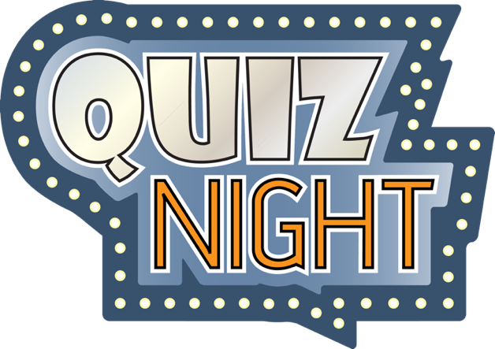

Saturday 22nd April
£10
Names to Margaret please

