FOR YOUR PRAYERS
THE PARISH CHURCH OF

www.allsaintstwickenham.co.uk
ALL SAINTS
TWICKENHAM
The Sick in body, mind or Spirit
D Catherine Wybourne, Tony Pescott-Day, Sam Cash, Bradley Smith, Lesley Harris, David Ballard, Rex Burwood, Vera Jolly, Richard Lowe, Kate Slack, Steve Randall, Chris Ctori, Merle Greisbach, Rae, Margaret McDonald, May Huggins, Samira Price, George and Lyn Pritchard.

Those suffering as a result of the Grenfell Tower fire.

All those being ordained at this time.

Nicholas Johnson, Richard Hume, Alexander Ladds, Adam Edwards, Aiden Edwards, Lee Taylor, Kyle Babin.

Those who have died.
Bishop David Thomas, Joyce Wylde, Les Blanchard.

Those whose anniversary of death is about now

1 | Dorothy Farley
3 | Ray Tye
5 | Elizabeth Carman
6 | Doreen Roberts;
6 | David Board
6 | Clifford Cross
7 | James Ilbury
9 | David Williams
9 | Olive Seago
10 | Greta Akehurst
13 | Isobel McInnes
 | Trisha Birdsall
14 | Richard John Absolon-Price
24 | Mavis Hall
25 | Fr Elfed Hughes
28 | Sarah Weston

WELCOME TO MASS
If you’re a visitor make yourself known to the parish priest.
Tea and coffee are served after Mass, please join us.
Little Saints – our Junior Church meet in the Hall
Please make sure your Mobile Phone is switched off.

Please take this sheet away with you

BEFORE MASS PLEASE KEEP A SENSE OF STILLNESS AND QUIET AS WE WAIT TO WELCOME THE LORD

12TH SUNDAY
of the year
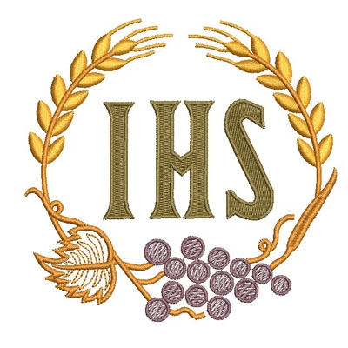
10am PARISH MASS

Today’s Gospel turns our thoughts to the strange phenomenon of persecution: throughout the history of mankind, the truth has been a commodity that often leads to persecution: the prophets of the Old Testament were attacked because of their message, as was the Lord Jesus himself. For his followers, the same may be true. The point of the readings is not simply to face up to the reality of the opposition the Gospel may meet, but to remember where the truth of the Gospel comes from: the Father in heaven, who knows us and values us. So we can be confirmed in our mission to witness to the truth, not fearing those who merely kill the body.

THE LITURGY THIS WEEK

TUESDAY S Cyril of Alexandria
0900 Lauds (Morning Prayer)
0930 MASS

WEDNESDAY S Iranaeus
0900 Lauds
0930 MASS
1830 Vespers (Evening Prayer)
1900 MASS

THURSDAY SS PETER & PAUL
0930 Lauds (Morning Prayer)
1845 Vespers
1930 MASS (Followed by refreshments)

FRIDAY 1St Martyrs of Rome
0900 Lauds
0930 MASS

SATURDAY Of our Lady
0900 Lauds
0930 MASS followed by church cleaning

NEXT SUNDAY

13TH SUNDAY OF THE YEAR
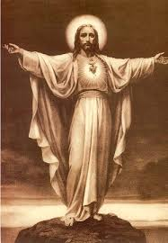

10am PARISH MASS
COMING UP

Saturday 15th July
12 Noon

At Churchwarden June’s !
£10
Names to June ASAP

SOCIETY OF OUR LADY OF PEW
Westminster Abbey

SUMMER EUCHARIST
& PROCESSION

21st July – 6.30pm

Mass setting: Guerrero – Missa Surge propera
Gradual Motet: Lassus – Salve regina a6
Communion Motet: Guerrero – Quae est ista
Processional Motet: Clemens non Papa – O Maria vernans rosa

