ALL SAINTS, TWICKENHAM

ALL SAINTS SUNDAY
Sunday 5 November 2017

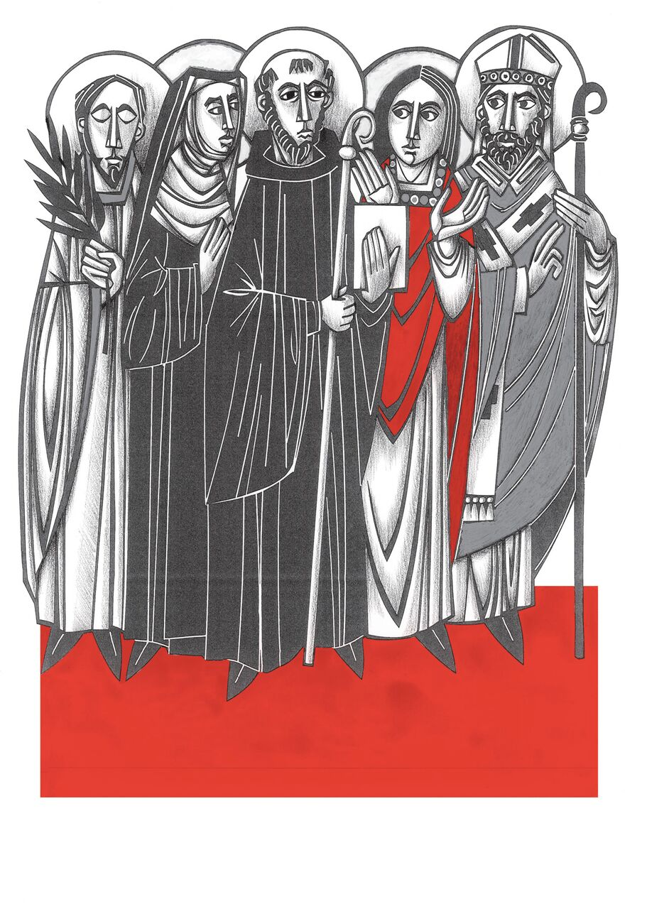

WELCOME TO MASS
If you’re a visitor make yourself known
to the parish priest.
Tea and coffee are served after Mass,
please join us.

Little Saints – our Junior Church meet in the Hall

Please make sure your
Mobile Phone is switched off.

BEFORE MASS PLEASE KEEP A SENSE OF STILLNESS AND QUIET AS WE WAIT TO WELCOME THE LORD

www.allsaintstwickenham.co.uk

THE LITURGY THIS WEEK

Tues
NO MASS TODAY

Wed
NO MORNING MASS
1830 Evening Prayer
1900 MASS

Thurs DEDICATION OF THE
LATERAN BASILLICA
0930 Morning Prayer
1000 MASS

Fri S Leo the Great
0900 Morning Prayer
0930 MASS

SatS Martin of Tours
0900 Morning Prayer
0930 MASS
NEXT SUNDAY
REMEMBRANCE SUNDAY

10am SOLEMN REQUIEM
& ACT OF REMEMBRANCE

FOR YOUR PRAYERS

The Sick in body, mind or Spirit
D Catherine Wybourne, Tony Pescott-Day, Sam Cash, Bradley Smith, Lesley Harris, David Ballard, Rex Burwood, Vera Jolly, Kate Slack, Steve Randall,, Merle Greisbach, Rae, Margaret McDonald, May Huggins, Samira Price, George and Lyn Pritchard, Rita Malyon, Ruth Maranzi.

Those who have died.

Those whose anniversary of death is about now

1 Bert Cornelious;
1 Monica Donovan
2 Kathleen Wisdom
6 George Bowditch
8 James Bowditch
10 FS George McInnes
16 John Murray
20 Ted Titman
23 Fr Leonard Charles Gillam
24 Philip Murphy
29 Elizabeth Akerman;
29 Roy Liffen
Peggy Owen

WELCOME TO OUR PREACHER
The Archdeacon of Middlesex
The Venerable Stephan Welch

